Religious Education

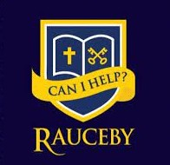

Igniting a passion for learning in all; emboldening a community of high aspiration and fulfilment.

‘I can do all things through him who gives me strength’. (Philippians 4.13)

#thischildcan

Approved by: | Julia Waites  Laura-Jayne Lill (Subject Leader) | Date: 01.09.26
Last reviewed on: | 01.09.26
Next review due by: | September 2027

Contents
1. Purpose of the policy 2
2. Subject vison 2
3. Aims and outcomes 3
4. Teaching and learning – Legal Requirement and responsibility of policy 4
5. Curriculum overview 4
6. Cross-curricular links 5
7. Assessment and recording 6
8. Resources 6
9. Roles and responsibilities 6
10. Inclusion 7
11. Monitoring and review 7

1. Purpose of the policy
This policy reflects the aims and values of Rauceby Church of England Primary School. It ensures all stakeholders, including staff, governors, parents and pupils, are working towards the same goals.
At Rauceby Church of England Primary School, we are committed to nurturing every child as a unique individual, created in the image of God, and inspiring them to achieve their full academic and personal potential. Rooted in our Christian vision and values, we hold high expectations for all pupils and provide a rich range of opportunities that enable every child to flourish. Through our Religious Education curriculum, we provide pupils with the knowledge, understanding and skills to explore Christianity and other world faiths and worldviews with curiosity, respect and openness. We encourage children to reflect on their own beliefs and values, develop empathy and compassion for others, and appreciate diversity within our local, national and global communities. Through Religious Education, pupils are equipped to engage thoughtfully with life's big questions and to contribute positively to the common good.
The purpose of this policy is to:
- Set out a framework for all teaching and non-teaching staff, giving guidance on planning, teaching and assessment
- Demonstrate adherence to the National Curriculum objectives and guidelines
- Provide clear information to parents and carers about what their children will be taught
- Allow the governing board to monitor the curriculum
- Provide Ofsted inspectors with evidence of curriculum planning and implementation

2. Subject vison
At Rauceby Church of England Primary School, our vision is to be an inclusive Christian community where every child is known, valued and inspired to flourish. Guided by the words of Philippians 4:13, "I can do all things through him who gives me strength," we believe that every child has the potential to achieve great things through faith, perseverance and the support of others. This belief is reflected in our school motto and hashtag, #thischildcan.

3. Aims and outcomes

At Rauceby Church of England Primary School, we are committed to providing a high-quality Religious Education (RE) curriculum for every pupil. Our curriculum reflects the ambition of the Lincolnshire Locally Agreed Syllabus for Religious Education 2025–2030, which states that RE should help pupils to develop the knowledge, insight, skills and understanding needed to engage with a wide range of religions and worldviews and to play a full and active part in a diverse society.

Our RE curriculum is rooted in our school vision: “To ignite a passion for learning in all; to embolden a community of high aspiration and fulfilment.” This vision underpins everything we do at Rauceby Church of England Primary School, ensuring that every child is encouraged to develop their curiosity, confidence and sense of purpose. Through our Christian foundation and our school vision, “I can do all things through Him who strengthens me” (Philippians 4:13), pupils are empowered to embrace challenge, pursue their individual curiosities and recognise their potential to learn, grow and flourish. This is embodied through our #thischildcan ethos, which celebrates the belief that every child can achieve, contribute and develop their own unique understanding of the world.

Through RE, pupils are encouraged to ask deep, meaningful and challenging questions about religion, belief, identity, values and the world around them. They develop a broad and balanced understanding of a diverse range of religious and non-religious worldviews, while recognising that diversity exists both between and within religions and worldviews. Pupils are supported to understand that people's beliefs and perspectives are shaped by a range of experiences and influences, and that there is no single way of understanding the world.



Our RE curriculum places a strong emphasis on developing both substantive and disciplinary knowledge.


Pupils are supported to understand not only ‘what’ they are learning, but also ‘how’ knowledge is developed, interpreted and explored. Through the disciplines of theology, philosophy and the human/social sciences, pupils learn to interpret religious beliefs and teachings, investigate the lived experiences of individuals and communities, and critically explore questions about truth, meaning, values and existence, our school character, Theo, Amari and Sophie support this, enabling pupils to become increasingly independent, thoughtful and confident thinkers. The development of pupils' individual worldviews is central to our approach. We recognise that every individual has a unique perspective shaped by their experiences, relationships, beliefs, values and understanding of the world. Therefore, our RE curriculum provides a safe, inclusive and respectful space in which pupils can explore their own ideas, reflect on their personal and spiritual development, and engage sensitively with perspectives that may be different from their own.

Our school values of aspiration, kindness, honesty, equality and forgiveness are woven throughout our RE curriculum and provide an important foundation for how pupils learn and interact with others. These values are not taught in isolation but are lived through our everyday school community and reflected in pupils' RE learning.

Ultimately, Religious Education at Rauceby Church of England Primary School is about enabling every child to flourish. Through our vision, values and #thischildcan ethos, we seek to ignite curiosity, build knowledge, develop courageous and respectful thinkers, and empower every pupil to understand themselves and others more deeply. We want every child to leave our school with the confidence to ask meaningful questions, the knowledge to engage with a diverse world, the skills to think critically and respectfully, and the aspiration to make a positive contribution to their community and beyond.

4. Teaching and learning – Legal Requirement and responsibility of policy
Rauceby Church of England Primary School has adopted the Lincolnshire Locally Agreed Syllabus for Religious Education provided by Lincolnshire’s Local Authority’s Standing Advisory Council on Religious Education. Following the requirements outlined in the Lincolnshire Locally Agreed Syllabus for Religious Education, the proportion of the curriculum time to be allocated to RE should be approximately;
- 36 hours per year in Key Stage 1
-45 hours per year in Keys Stage 2
In Reception, Religious Education should be delivered flexibly according to the statutory requirements of the EYFS Framework and to help meet the early learning goals (ELG). Nursery classes have a non-statutory requirement.
Right of withdrawal
Parents/Carers Parents/carers may withdraw their children from all or part of the RE curriculum [Education Reform Act 1988, S2 (1)(a)]. They do not have to provide a reason for this, and the school must comply with the request. It has a responsibility to supervise any pupils who are withdrawn from RE but is not required to provide additional teaching or incur extra costs. If parents/carers wish their child to receive an alternative programme of RE it is their responsibility to arrange this. This could be provided at the school in question or another local school. The pupil may receive external RE teaching if this does not significantly impact on his/her attendance.
Teachers may withdraw from the teaching of RE on the grounds of conscience unless they have been specifically employed to teach or manage the subject.

5. Curriculum overview
Our Religious Education curriculum has been carefully structured and planned following the Lincolnshire Locally Agreed Syllabus for Religious Education guidance to develop pupils’ knowledge, skills and understanding in a progressive and coherent way. Learning is sequenced year by year to ensure clear progression, building on prior knowledge and revisiting key concepts to deepen understanding.
The units of study for each year group include carefully sequenced medium-term plans, covering one term or more. For each year group, guidance identifies the religions and worldviews (RWs) that must be covered, ensuring that Christianity, alongside the other principal religions represented in Great Britain.
To ensure continuity, progression and coherence across the RE curriculum, Rauceby Church of England Primary School follow the themes identified for each year group, alongside the key learning questions for each unit.
Alongside the core units of study, case studies developed in collaboration with the Lincoln Diocese are incorporated into teaching where appropriate. These case studies provide pupils with opportunities to explore religious beliefs and worldviews through authentic examples and real-world contexts. They support pupils in developing a deeper understanding of the subject by enabling them to make meaningful connections between their classroom learning and the lived experiences of individuals and communities.
A non-subject specialist may find it helpful to follow the plans closely as set out, while experienced teachers may choose to adapt and enrich the content to meet the needs and interests of their pupils. All approaches are overseen by the subject leader, who is responsible for maintaining an overview of curriculum progression, ensuring that knowledge and understanding build coherently from Reception onwards.
Elements of the RE syllabus may also be reinforced through Collective Worship and a range of wider learning experiences, including visits, visitors to school, opportunities to engage with members of faith communities and the use of the Lincoln Diocese case studies. These experiences enhance pupils' understanding of religion and worldviews and provide valuable opportunities to apply and extend their learning beyond the classroom.
At Rauceby Church of England Primary School we have developed a clear and accessible approach to teaching religion and worldviews through the use of carefully chosen characters. These characters provide pupils with familiar and engaging reference points to support their understanding of worldviews and encourage them to ask and explore big questions about religion, belief, identity and the world around them.
The characters are used throughout the RE curriculum and Collective Worship to help pupils develop their personal knowledge, alongside both substantive and disciplinary knowledge. They support pupils in making connections between what they already know, new learning and the different ways in which people understand and respond to questions of meaning, belief and values.
The three key disciplines of RE: Theology, Human/Social Sciences and Philosophy
They are represented through dedicated characters: Theo (Theology), Amira (Human/Social Scientist) and Sophie (Philosophy). Each character provides pupils with a distinct lens through which to explore and understand religion and worldviews.
The use of these characters helps to make the different disciplinary approaches explicit and accessible to pupils, while encouraging them to become confident, curious and reflective thinkers. Over time, pupils are supported to use these different lenses independently, developing a deeper and increasingly sophisticated understanding of religion and worldviews.
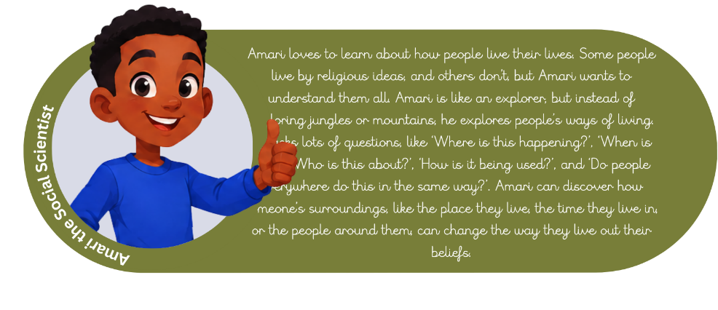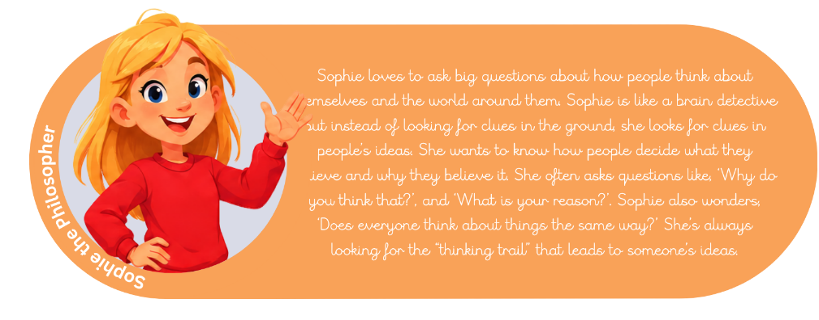

6. Cross-curricular links
At Rauceby Church of England Primary School, our Religious Education (RE) curriculum equips pupils with the knowledge, skills and confidence they need to become respectful, thoughtful and high-aspiring learners. Through a carefully planned and progressive RE curriculum, pupils are encouraged to develop their understanding of religion and worldviews while making meaningful connections between their learning, their own lives and the wider world.
Our RE curriculum provides pupils with opportunities to apply our school vision in all that they do: to ignite a passion for learning in all; to embolden a community of high aspiration and fulfilment. Pupils are encouraged to ask questions, explore different beliefs and perspectives, reflect thoughtfully and engage respectfully with ideas that may differ from their own and all areas of the curriculum.
The element of challenge is embedded throughout our RE curriculum, reflecting our school motto, #thischildcan. Pupils are encouraged to embrace challenge, develop confidence in expressing their ideas and recognise that they can achieve highly when they are supported to persevere and think deeply.
Learning in RE is enriched through opportunities to make connections beyond the classroom and is celebrated through our #thisfamilycan experiences. These experiences enable pupils and their families to engage with faith, religion and worldviews together, strengthening our school community and celebrating the achievements and learning of every child.

7. Assessment and recording
7.1 Assessment and 7.2 Recording
RE will be monitored by the subject leader on a termly cycle and with reference to the school development plan. It will be monitored in a variety of different ways, including; work sampling, pupil voice, teacher voice, lesson drop-ins and governor monitoring.
At Rauceby Church of England Primary School we plan and asses our Religious Education Curriculum against the Progression Strands outlined in Lincolnshire Locally Agreed Syllabus 2025-2030.
7.2 Recording
In RE, pupils will record their learning in the following ways:
- Verbal discussions captured digitally or on working walls
- RE books

8. Resources
8.1 Textbooks and other equipment
Resources include:
- RE books
- Variety of religious and different faiths textbooks for appropriate for primary aged children
- Visual prompts and differentiated tools to support learners with additional needs.
- Lincolnshire Diocese case studies to support RE lessons and religious concepts
8.2 External speakers, local museums, trips
External speakers include:
- Termly visits and services at St Peter Rauceby Church
- Visits to places of worships – mosques, churches, cathedrals
- Visits from different religions and faiths – Hindu experience workshop
- Local church festival
- Visits from local Rauceby church community

9. Roles and responsibilities
9.1 Headteacher
The headteacher at Rauceby Church of England Primary School will:
- Support the subject leader but also hold them to account for the effectiveness of the subject
- Support staff through the provision of training and resources
- Monitor the planning and delivery of the subject
- Ensure the requirements of the National Curriculum are met
- Ensure this policy is reviewed according to the timescales set out
9.2 Subject leader
The subject leaders at Rauceby Church of England Primary School will:
- Prepare and review subject policy and curriculum plans
- Promote the study of the subject throughout the school
- Monitor the teaching and assessment of the subject
- Attend appropriate CPD
- Stay informed regarding developments in the study and teaching of the subject
- Evaluate resources
- Provide training and CPD to staff on the subject curriculum and its delivery, and keep them informed about subject developments nationally
- Assess the impact of the subject curriculum on pupils’ learning and development
- Make presentations to governors on the subject and how it is being taught
9.3 Link governor
The governors responsible for teaching and learning at Rauceby Church of England Primary School will:
- Monitor the impact of the subject across the school and on pupils
- Monitor teacher workload and professional development
- Ensure subject action plans are suitable
- Monitor the quality of resources
- Keep track of pupil and parent engagement with the subject
- Keep up to date with the curriculum (what's taught, why it's taught, and how it's taught)
9.4 Classroom teacher
Classroom teachers at Rauceby Church of England Primary School will:
- Teach and assess the subject according to the principles laid out in this policy
- Report to the subject leader
- Maintain subject knowledge and appropriate CPD
9.5 Parents
The parent community at Rauceby Church of England Primary School will:
- Make sure their children are prepared for learning
- Monitor the completion of homework

10. Inclusion
All pupils have access to RE, with teaching adapted to meet individual needs. Support includes differentiated resources, scaffolding, and visual prompts to ensure equal access to the curriculum. Lessons are designed to celebrate diversity and provide meaningful challenge for every learner. Teachers set high expectations for all pupils in RE. They will use appropriate assessment to set ambitious targets and plan challenging work for all groups, including:
- More able pupils
- Pupils with low prior attainment
- Pupils from disadvantaged backgrounds
- Pupils with special educational needs (SEN)
- Pupils with English as an additional language (EAL)
Teachers will plan lessons so pupils with SEN and/or disabilities can study RE, and ensure that there are no barriers to every pupil achieving.
Teachers will also take account of the needs of pupils whose first language is not English. Lessons will be planned so that teaching opportunities help pupils to develop their English, and to support pupils to take part in RE.
Further information can be found in our statement of equality information and objectives, and in our SEN policy and information report.

11. Monitoring and review
- The RE subject leader monitors planning, teaching, assessment, and pupil outcomes through regular audits, lesson observations, work scrutiny, and pupil voice.
- The effectiveness of the RE curriculum and policy is reviewed annually, with input from staff, pupils, and governors, whilst ensuring it aligns with Lincolnshire Locally Agreed Syllabus 2025-2030
- Action plans are developed to address identified areas for improvement, including curriculum coverage, progression, inclusion, assessment, and resource management.
- The policy is updated in response to changes in statutory guidance, inspectorate expectations, and school priorities.
This policy will be reviewed by staff and governors every year.

